What's That Sound?
Close your eyes. What do you hear? If you're in the country, you might hear birds chirping or wind blowing through the trees. In the city, you might hear horns honking, sirens blaring, and cars revving their engines. In the classroom, you might hear a pencil tapping, keyboards clacking, and the occasional gaseous expulsion from someone after lunch. Regardless of where you are, sounds will be there. Yes, even when a tree falls in the forest and no one is there to hear it, it still makes a sound.
So how do sounds work?



Organize What You Learn
Use this graphic organizer, which is a "fact sheet" for sound waves, to compare ideas about sound.

The Wave of Sound
Sounds are all around you. They are a special kind of mechanical wave that have a variety of applications. The properties of this wave allow it to be manipulated and used for entertainment and medical procedures. You will learn about the various properties of sound and how these properties are used in different applications.


Sound as Compression
A sound wave is a disturbance that travels through various mediums and can be detected by the human ear. Unlike other mechanical waves, the disturbance cannot be seen because sound primarily travels through air. When sound travels through air, it travels as a longitudinal wave, meaning its disturbance is parallel to its motion. The air particles oscillate back and forth while the sound travels. At certain points in the wave, the air particles are more tightly packed, and at other points in the wave, the air particles are spread out. This creates alternating regions of high and low pressure. It is for this reason that longitudinal waves are also referred to as compression waves.
How well do you understand the concept of sound as compression?

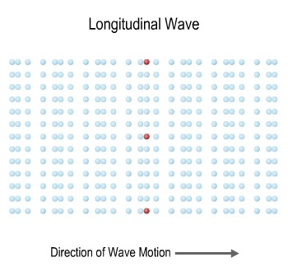

How Sound Travels
Sound waves are able to travel through different mediums. The most common medium that a sound wave travels through is air, but it can also pass through liquids and solids.
Submarines use sound waves called, sonar, underwater to locate objects around the submarine. Sound is able travel through solids as well. This explains why it is possible to hear someone behind a wall. Sound travels even faster in solids than both liquids and gases because the particles in a solid are very tightly packed.
When a sound wave enters a different medium, its physical properties can change. For example, sound travels at a speed of 1,482 m/s in water, which is much faster than the 343 m/s it travels in air.

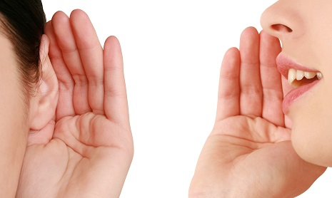

Do You Hear an Echo?
When you yell into a canyon, or maybe a large auditorium, you can produce an echo. How does an echo occur? As a sound wave travels through air, it has the freedom to move forward until it reaches a barrier. When a sound encounters a barrier, it is reflected by the barrier. The direction of the reflected sound wave depends upon the angle at which it approaches the barrier. The reflection of the sound wave is the echo you hear.



Applications
Without a doubt, sound has numerous applications. From enjoying your favorite song to communicating to one another, sound is used in everyday life. Sound is also used in the medical field for a variety of purposes.

Galleria

Pregnancy
Image of an ultrasound machine.

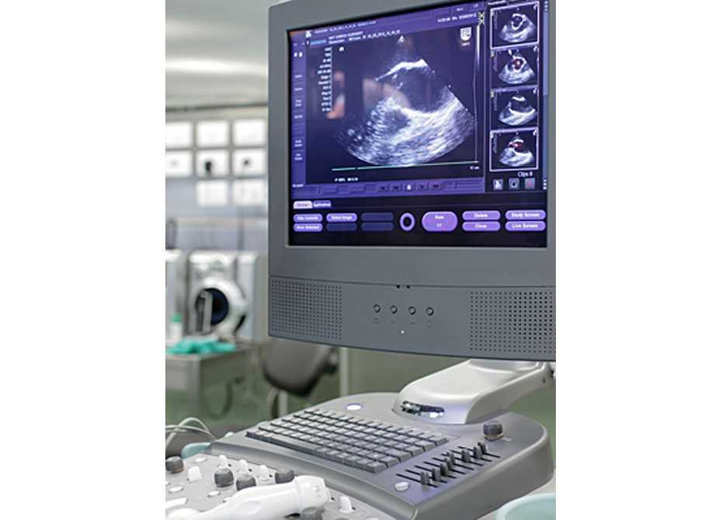

Ultrasound is a technique that uses sound waves to monitor babies in the womb.

Surgery
Image of surgeons in the operating room.


New advances in technology may allow sound waves to be used as a precise cutting instrument for surgeries. The sound waves are focused on a tiny area, causing the “slice” in the desired area. This could be the future of noninvasive surgery.

Treatment
Image of operating theatre staff wearing scrubs.


Ultrasound is used as treatment for people with kidney stones. The high energy sound wave vibrates the stones until they break down, making them easier to pass.

Vital Signs
Image obstetrician checking a pregnant woman.


Sound is used to check a person’s heartbeat and blood pressure. A stethoscope detects the sound of blood pumping in your vessels and heart.

Investigating Sound
Now that you have learned about how waves travel and the mechanics of sound waves, let's investigate sound waves to compare the motion of objects to the sounds one actually hears.

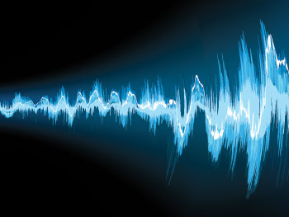

Study Club: Investigating Sound

Screen 1

The Materials

Photograph of materials: approximately two meters of cotton string, approximately two meters of thin wire, scissors, small paper clips, plastic wrap, two rubber bands, metal spoon, plastic metric ruler, a cardboard tube from plastic wrap or paper towel roll.

Jeremy: I looked around the house to gather the materials I needed for this investigation:
approximately two meters of cotton string
approximately two meters of thin wire
scissors
small paper clips
plastic wrap
two rubber bands
metal spoon
plastic metric ruler
a cardboard tube from plastic wrap or paper towel roll
I then found a clear space on a table to complete the activities. After printing the assignment worksheet, I was ready to begin.
Making Sound with a Ruler
Jeremy placed the ruler on the table with about 10 cm hanging over the edge. He then lifted up on the end of the ruler and let go.
Look at what he did and the observations he made.

Accordion: Ruler

Directions: Select a header to expand or collapse content in each section.

Photograph of a ruler on a table with part of it over the edge.

Section 1: Jeremy Presses on Ruler and Releases It

Photograph of a ruler on a table with part of it over the edge. Two fingers are pushing down on the portion hanging off.

Section 2: What Jeremy Saw

When Jeremy released the ruler he watched it vibrate up and down. He noticed that the vibrations got smaller. In other words, the distance the ruler traveled up and down became shorter and shorter until the ruler stopped vibrating.

Section 3: What Jeremy Heard

The vibrating ruler made a flapping sound that got softer as the vibrations of the ruler slowed down.
Example Problem: Cardboard Tube

Directions: View each step below in the example problem.

Cardboard Tube
Image of cardboard tube with plastic wrap on each end, secured by a rubber band.

Jeremy stretches a sheet of plastic wrap over each end of a cardboard tube. He secured both sheets of plastic wrap with a rubber band so that it was held taut.

“Thumping”
Image of cardboard tube with plastic wrap on each end, secured by a rubber band. A boy has his hand over one end of the tube while he taps his finger on the other end.

Jeremy thumped the plastic wrap on one end of the tube with his finger while gently holding his hand over the other end of the tube. The plastic wrap made a thumping sound. Each time Jeremy thumped the wrap with his finger, he felt air pushing down the wrap against his hand on the other end.

Paper Clip
Image of cardboard tube with plastic wrap on each end, secured by a rubber band. A paper clip rests on one end of the plastic wrap. The paper clip is not touching the sides of the tube.

Jeremy placed a paper clip on the plastic wrap at the top of the tube. He made sure that the paper clip did not touch the sides of the cardboard tube.

Thumping & Clip
Image of cardboard tube with plastic wrap on each end, secured by a rubber band. The cardboard tube is held vertically. The paper clip sits on the top end of the tube while the boy taps the bottom.

Jeremy held the tube with the paper clip vertically and thumped the bottom plastic wrap. Each time he tapped the plastic wrap he heard the same thumping sound he had heard previously. This time each thump resulted in air pushing against the top layer of plastic wrap and causing the paper clip to bounce up and down.

Example Problem: Metal Spoon

Directions: View each step below in the example problem.

Metal Spoon

Photograph of a metal spoon

Jeremy held a metal spoon above the table and allowed it to fall.

Spoon Drop #1

Photograph of a metal spoon falling to a table

When the spoon fell, the bowl of the spoon hit the table first. It bounced up and down on the surface. When the spoon first hit the table it make a clanking sound and then as it bounced again it made a pinging sound.

Spoon & String

Photograph of a metal spoon tied with string

Next, Jeremy tied a one-meter length of cotton string around the metal spoon so that the metal spoon was in the middle of the string.

Spoon Drop #2

Photograph of a spoon being held by string

Jeremy twirled the string around the first finger of each hand.

Results #2

Photograph of string next to a person’s ear

Jeremy placed his fingers in his ears and allowed to spoon to drop to the table. He heard the vibration of the metal spoon against the table through the string.

Spoon & Wire

Photograph of wire

Jeremy wound a one-meter length of wire around the metal spoon so that the metal spoon was in the middle of the string. He then carefully wound the string around the first finger of each hand.

Spoon Drop #3

Photograph of wire next to a person’s ear

Jeremy carefully placed his fingers in his ears, making sure the metal wire did not enter his ear canal. He allowed the spoon to drop to the surface. He heard the vibration of the spoon through the wire, but noticed the sound was louder through the wire than it was through the string.

Assignment: Sound Waves Investigation
Use the data and observations from the experiment to answer the questions in this assignment.

